

**Project Name:**Women Wellness Saturday Clinic

**Team:** Medra, Marketing Team,

**Project Summary**

According to a survey conducted in 2023, almost 50% of women in the United States are forgoing preventive care like checkups, screening, and vaccines due to time constraints, cost of visits, lack of insurance, and racial disparities. (Strand, 2022)

Erlanger Western Carolina is committed to changing this trend by promoting women's health in the Cherokee, Clay, and Graham County regions. In the past, they have held a monthly Saturday day clinic, especially for women, called Ladies Day In. Recently, attendance at this monthly event has begun declining. The Marketing team, in connection with EWCH, has renewed the focus on women's health by doing the following:

• Changing the Name of Lady’s Day In to Women's Wellness Saturday Clinic

• Increase community awareness about this event

• Rebranding our message to better suit our target audience

• Encouraging women that time, money, lack of insurance, and race should not be a reason for ignoring health

• Create a Comprehensive marketing strategy

The scholarship program assists those without or whose insurance does not cover the cost of annual checkups. The process for attending the clinic is simple. Regardless of insurance status or ability to pay, women who reside within the region may schedule a Saturday appointment from 8 - 12 p.m. This event generally occurs at the clinic, but women who attend must walk to the Radiology lab for Mammograms. The primary provider for this clinic is Kay Hayes

**Background**

Women's Wellness Saturday Clinic encourages women in the Murphy region to schedule annual checkups on a specific Saturday Clinic every month. We must understand the strategic barriers we face to ensure that the number of women scheduling an appointment increases. The barriers are:

* Insurance - Women with poorer self-reported health status are almost twice as likely as those in better health to have gone without insurance at some point in the prior year. (Usha Ranji, 2018)
* Cost - Roughly one in four (26%) women forego care due to cost (Usha Ranji, 2018)
* Time - Transportation and childcare also present barriers to care but to a lesser degree. These barriers affect women of all income levels, but low-income women more commonly experience childcare and transportation problems. (Usha Ranji, 2018)

As part of a renewed commitment to the Women's Wellness Saturday Clinic and overcoming the barriers affecting attendance volumes, the marketing team will create a comprehensive strategy for educating women on the benefits of taking time for their health.

**Objective**

*Erlanger Western Carolina will increase women's health service patient volume by 5% by July 2024 by promoting women's wellness Saturday clinic.*

To achieve 5% patient growth. We must focus on two goals to increase Women's Wellness Saturday Clinic attendance. The max capacity for the clinic is 20 patients. The average monthly attendance for lady’s day in is 5-10 appointments

* Increase Average Monthly Women’s Wellness Saturday Clinic attendance by 2.5% by July 2024.
* Increase average Monthly Women’s Wellness Saturday Clinic in Patient referrals by 3.5% by July 2024.

Focusing on the stated goals will help us to measure the success of the Women's Wellness Saturday Clinic. We will measure success by tracking attending and patient referrals every quarter. We will evaluate the goals and make changes if volumes stay the same.

**Role in the Marketing Mix**

Women's Wellness Saturday Clinic plays a vital role in the community by raising the overall health level in Cherokee, Clay, and Graham Counties. According to County Health rankings:

* Cherokee (CE) ranks among the least healthy counties in North Carolina (Lowest 0%-25%)"
* Clay (CY) ranks in the higher mid-range of counties in North Carolina (Higher 50%-75%)."
* Graham (GR) ranks in the lower middle range of counties in North Carolina (Lower 25%-50%).

The research shows the rate of women in each county who receive their yearly mammogram:

* 36% Cherokee
* 38% Clay
* 25 % Graham

These are only a few data points showing the need to focus on women's services in Western Carolina.

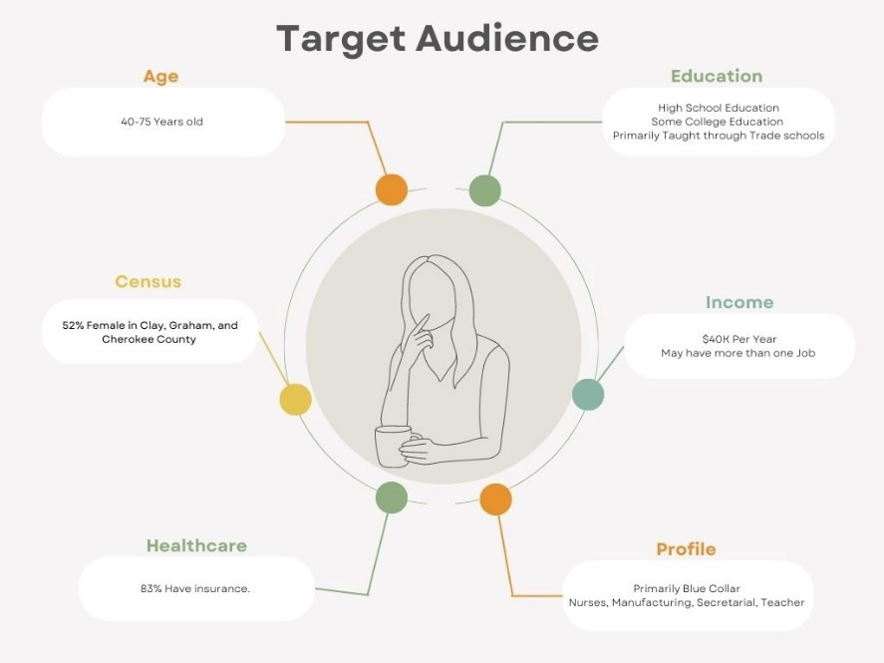**Target Audience**

* Age: 40-75 years’ old
* Income: $40K Per Year
* Education: At least a High School Education
* Male / Female: Female
* Ratio: Average 52%, Female
* Profile: Primarily Blue Collar - Manufacturing, Farming, Secretarial Positions, Nurses,
* Insured: 83%

The audience for this campaign will primarily be Caucasian and may have more than one job. If our target audience is married, both spouses may work in a blue-collar position.

The patient may need more time to call and schedule the appointment and may not be available due to a strict work schedule. The unique benefit of this clinic centers around time. Erlanger Western Carolina has created the clinic specifically for those who do not have time during the week to schedule a physical or wellness checkup.

**Insight**

Women with insurance have better access to care, but some still face barriers, such as services that are not covered and expensive cost-sharing. Affordability continues to be a challenge, with many women reporting they could not afford preventive care, treatments, or prescription medicines because of the out-of-pocket costs. In addition, some barriers are because women do not have time to seek care or do not have workplaces that support them in taking time off to go for appointments.

Our target audience cares about this effort because the Women's Wellness Saturday Clinic offers an opportunity for those who are too busy during the week to schedule a check-up. We want our audience to demonstrate their need for this effort by visiting Women’s Wellness on Saturday Clinic.

**Behavior**

Changing recent behavior is essential to assist women with taking care of their health. According to a recent survey completed in 2023, "nearly half of American women (45%) have forgone preventive care services like check-ups, tests, treatments, and vaccines in the last year. When asked why, women cite being unable to afford out-of-pocket costs (25%) and limited time to schedule appointments (23%) as the top reasons." (Prevention, 2023)

If we aim to encourage women to make time for themselves, we must understand why this is not happening. The barriers include:

* Lack of Time
* Cost
* Lack of Knowledge
* Distance from Location

As a result of our campaign, we want women in Clay, Cherokee, and Graham counties to:

* Take pride in their healthcare by attending Women's Wellness Saturday Clinic
* Make time for their health
* Show that taking time today for healthcare means it is less likely that our audience will be sick later
* Understand that Cost, Time, and insurance will affect them later by ignoring their health
* Increase the number of women who visit EWCH Providers Regularly for annual checkups

**Key Messaging**

 Focusing on the smaller objectives above will help our audience understand that living healthy now means living healthy later. Our target audience will need to believe that a check-up is essential to living a happy and healthier life. As a result of this belief, our audience will understand that the best place to get annual checkups is Erlanger Western Carolina Hospital in Murphy.

The belief barriers that need to be overcome are:

* I do not have time
* I do not have the money
* I do not need this checkup,
* It is too far to drive

**Brand Development/RTB**

We aim to increase women's patient volumes by focusing on Women's Wellness Saturday Clinic. The critical factor in the aim is to ensure that Erlanger's Brand is on everybody's mind. We want our audience to understand why the best place for women's health services is at Erlanger.

**The Why:** We make healthy choices every day for different reasons. You support your family, provide for your community, help your friends, or enjoy the outdoors; whatever the reason for choosing to be healthy, Erlanger wants you to be healthy for all of it. Visit Women's Wellness Saturday Clinic and complete an annual check-up. Visit Erlanger.org/WWS

**Success Criteria**

Understanding current patient data in the region is essential to measuring key performance indicators.

* 37% of Clay, Cherokee, and Graham Counties women complete a yearly mammogram.
* Between 12% and 34% of families in the service area have struggled to fulfill basic needs.
* Among those earning less than $25,000 annually, 38% said they have been unable to get medicine or health care when needed at least once in the past year.

**Key Performance Indicators (KPI)**

Increase the number of scheduled women's health appointments

Increase attendance at the Women's Wellness Saturday Clinic

Increase awareness of Erlanger women's services in Clay, Cherokee, and Graham Counties.

**Strategy Review**

3 Month strategy review: December 15th

6 Month strategy review: March 15th

Annual strategy review: July 1st

**Timing**

Release Dates

Relaunch: Oct 1, 2023

Media Release: Sept 28th

Appointment availability: Oct 1, 2023

**Clinic Dates:**

* Oct 21st
* Nov 18th
* Dec. 16th
* Jan. 20th
* Feb. 17th
* March 16th
* April 20th
* May 18th
* June 22nd
* July 20th

**Deliverables**

* Geo-fencing - 25 Mile Radius

(Reaching into Cherokee, Clay, and Graham Counties) *

* Media Release (Cherokee Scout)
* Snap-on / Harrah’s - Digital and Print
* On Hold Messaging
* 4 x 6 Book / Notes/ Calendar * (*\*Getting quotes before giving approval)*
* Radio
* Outdoor Billboards
* Blogs / SME’s featuring Common Health Concerns
* Develop Web Page

**Design Concepts**

**Key Message**

You are the organizer, the champion, and the friend that’s always giving. Isn't it about time you take care of your health? Women's Wellness Saturday Clinic offers annual check-ups to keep doers like you healthy so you can be around to continue giving. Call 828-837-3525 to schedule an appointment, or Visit Erlanger.org/wws.org to learn more.

**Artwork Design Concepts**

Moms at Soccer Practice, Work, Grocery Store, Hiking, ETC.

**Mandatories& Considerations**

The overall strategy of Erlanger Western Carolina is to increase the patient experience and raise awareness of health services offered at the clinics and hospitals. Increasing attendance at Women's Wellness Saturday Clinic will help the hospital retain its stronghold in the region.

**Brand tone**:

Approachable Authority.

**Closing Summary:**

Women's Health and Prevention (AWHP) reveals that nearly half of American women (45%) are forgoing preventive care services like check-ups, screenings, and vaccines, and the inability to afford out-of-pocket costs is the most common reason women cite for skipping this critical care. The survey of 3,204 women examined their experiences with preventive healthcare, the challenges they face accessing it, and the existing disparities. (Prevention, 2023) Erlanger Western Carolina seeks to be the hospital for all of the region by promoting healthcare services that assist patients with living healthy instead of just being healthy.

# References

Prevention, A. F. (2023, January 31). *https://www.prnewswire.com/news-releases/new-ipsos-survey-reveals-nearly-half-of-american-women-forgo-preventive-care-services-301734081.html*. Retrieved from https://www.prnewswire.com/news-releases/new-ipsos-survey-reveals-nearly-half-of-american-women-forgo-preventive-care-services-301734081.html: https://www.prnewswire.com/news-releases/new-ipsos-survey-reveals-nearly-half-of-american-women-forgo-preventive-care-services-301734081.html

Strand, G. (2022, May 10). *https://mygrandstrandhealth.com/blog/entry/the-importance-of-annual-well-woman-visits*. Retrieved from https://mygrandstrandhealth.com/blog/entry/the-importance-of-annual-well-woman-visits.

Usha Ranji, C. R. (2018, March 13). *https://www.kff.org/womens-health-policy/issue-brief/womens-coverage-access-and-affordability-key-findings-from-the-2017-kaiser-womens-health-survey/*. Retrieved from https://www.kff.org/womens-health-policy/issue-brief/womens-coverage-access-and-affordability-key-findings-from-the-2017-kaiser-womens-health-survey/.